St. Joseph School
1413 – 23rd Avenue, Coaldale, Alberta T1M 1L6
Phone: 403-345-3373 Fax: 403-345-3789

Kevin Kinahan, Principal kinahank@holyspirit.ab.ca
Brent Christensen, Associate Principal christensneb@holyspirit.ab.ca

JH Band Syllabus

Days: Monday, Wednesday
Time: Period 9

You must bring: your instrument, your folder (containing your cheat sheet booklet, music, fingering chart, homework book, pencil, and practice sheet).

During the year, you will be graded in 4 ways:
- Weekly mark (30%)
- Show what you know (15%)
- Concerts (15%)
- Practice sheets (40%)
Weekly mark: This mark is based on your attendance, your preparedness, and your efforts. (See marking rubric below.

Show what you know: These will be based on either a scale or section of a piece we are learning. You will not know ahead of time exactly what you will play. You will only be demonstrating what you know based on what we have worked on in class.
These will be done on:
September 19th
October 3rd
October 17th
October 31st
November 14th
November 28th
December 5th
January 16th
January 30th
February 6th
February 27th
March 13th
March 20th
March 27th
April 10th
April 24th
May 1st
May 15th
May 29th
June 5th

Concerts: We have three concerts throughout the year (December 13th, March 13th, June 11th). These concerts are part of your final grade. Your participation in the concerts are vital and lead to the overall success of our band program.

Practice sheets: Remember, practicing is what you do in your own time, class time is a rehearsal. It is VITAL that you practice on your own time. As stated on the practice sheets, JH students should practice for around 90 minutes per week; that’s less than 15 minutes a day. Practice sheets are due by the end of day Thursday, signed by a parent. Unsigned sheets will not be counted.

Band Camps:
This year, since we are such a small band, we will not be doing the big trip to SABC. Instead, we are going to do three separate one day sessions at the UofL working with professional musicians and their band director. (Anyone in grade 7 will remember him from last year). On two of the three trips, the grade 6’s will join us; the third trip is just for you. Our goal is to have improved every time they see us so they do not have to work on the same thing each time we go.

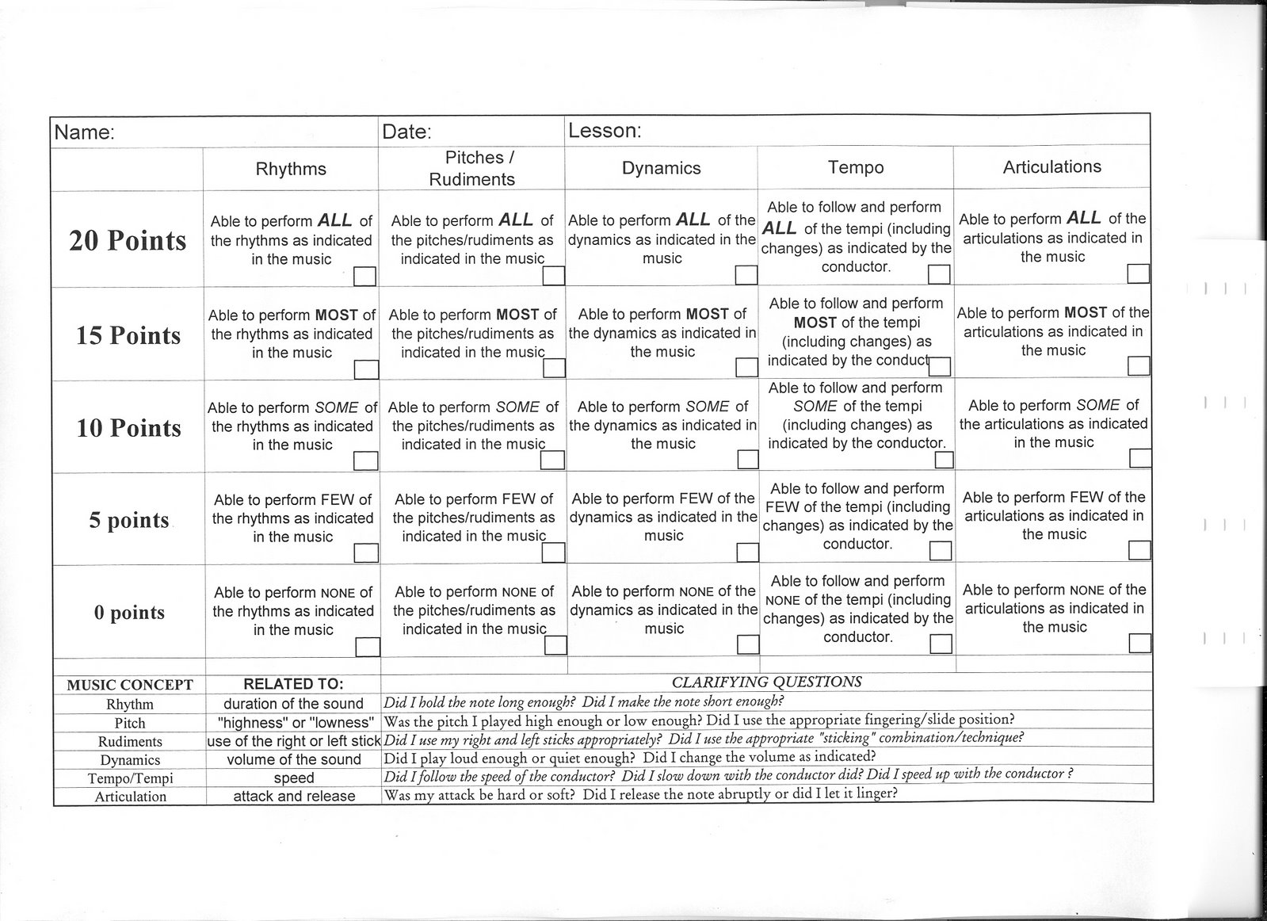
Show what you Know Rubric

